PIZZA SALES SQL QUERIES

1. KPI’s
2. Total Revenue :

SELECT SUM(total_price) AS Total_Revenue FROM pizza_sales;

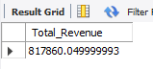

1. Average Order Value :

SELECT

ROUND((SUM(total_price)) / (COUNT(DISTINCT order_id)),

2) AS Average_Order_Value

FROM

Pizza_sales;

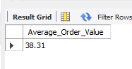

1. Total Pizza Sold :

SELECT SUM(quantity) AS Total_Pizza_Sold from pizza_sales;

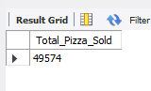

1. Total Orders :

SELECT COUNT(DISTINCT order_id) AS Total_orders FROM Pizza_sales;



1. Average Pizza’s per order :

SELECT (SUM(Quantity) / COUNT(distinct order_id)) AS Avg_pizzas_per_order from pizza_sales;

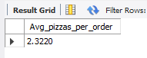

**B. Daily Trend for Total Orders**

SELECT DAYNAME(order_date) AS Order_day, COUNT(DISTINCT order_id) AS Total_orders FROM pizza_sales GROUP BY Order_day;

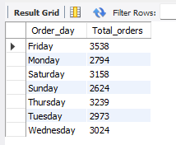

**C. Monthly Trend for Orders**

SELECT MONTHNAME(order_date) AS Order_month, COUNT(DISTINCT order_id) AS Total_orders FROM pizza_sales GROUP BY order_month ORDER BY Total_orders DESC;

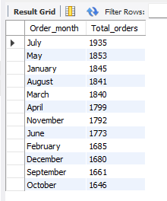

**D. % of Sales by Pizza Category**

SELECT pizza_category,

ROUND((SUM(total_price) / (SELECT SUM(total_price) FROM pizza_sales) * 100), 2) AS Percentage_Contribution

FROM pizza_sales GROUP BY pizza_category

ORDER BY Percentage_Contribution DESC;

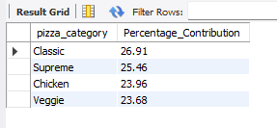

**E. % of Sales by Pizza Size**

SELECT pizza_size,

ROUND((SUM(total_price) / (SELECT SUM(total_price) FROM pizza_sales) * 100), 2)

AS Percentage_Contribution FROM pizza_sales

GROUP BY pizza_size ORDER BY Percentage_Contribution DESC;

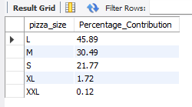

**F. Total Pizzas Sold by Pizza Category**

SELECT Pizza_category, SUM(quantity) AS Total_Sold_no

FROM pizza_sales GROUP BY pizza_category;

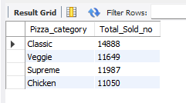

**G. Top 5 Pizzas by Revenue**

SELECT Pizza_name, sum(total_price) As Revenue

from pizza_sales group by Pizza_name order by Revenue desc Limit 5;

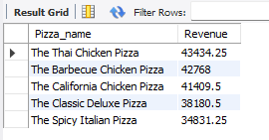

**H. Bottom 5 Pizzas by Revenue**

SELECT Pizza_name, sum(quantity) As Total_Quantity

from pizza_sales group by Pizza_name order by Total_Quantity desc Limit 5;

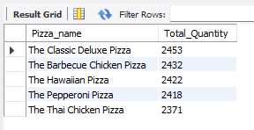

**I. Top 5 Pizzas by Quantity**

SELECT Pizza_name, Count(distinct order_id) AS Total_Order FROM Pizza_sales GROUP BY Pizza_name ORDER BY Total_order desc LIMIT 5;

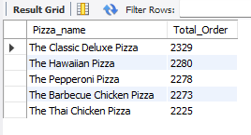

**J. Bottom 5 Pizzas by Quantity**

SELECT Pizza_name, sum(total_price) AS Revenue

FROM pizza_sales GROUP BY Pizza_name ORDER BY Revenue LIMIT 5;

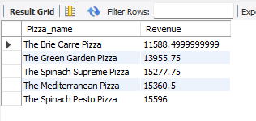

**K. Top 5 Pizzas by Total Orders**

SELECT Pizza_name, sum(quantity) As Total_Quantity

FROM pizza_sales GROUP BY Pizza_name ORDER BY Total_Quantity LIMIT 5;

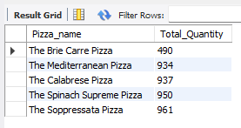

**L. Borrom 5 Pizzas by Total Orders**

SELECT Pizza_name, Count(distinct order_id) AS Total_Order FROM Pizza_sales GROUP BY Pizza_name ORDER BY Total_order LIMIT 5;

